S.4.4 Correlation between movement speed and other factors

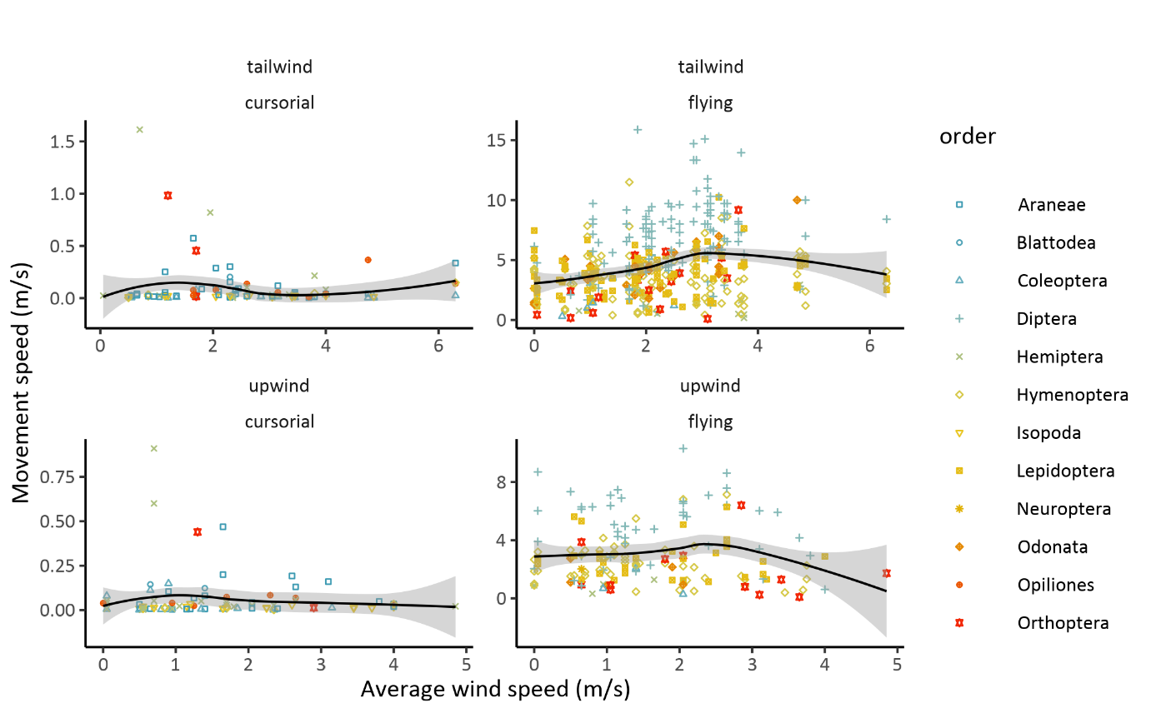

Figure S.4.4.1: The effect of the wind speed on the movement speed of cursorial and flying individuals, separated in upwind and tailwind conditions.

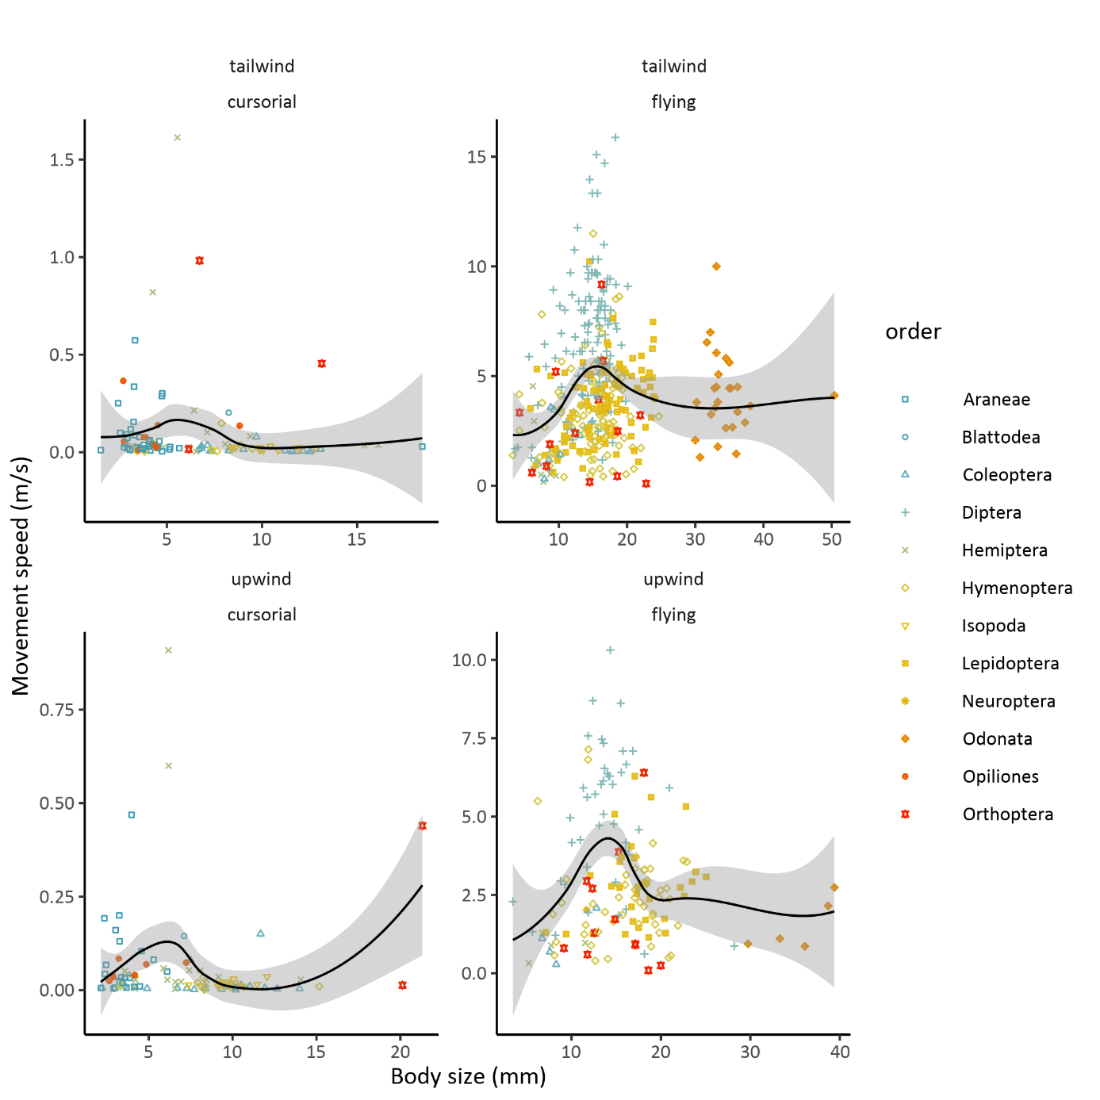

Figure S.4.4.2: The effect of the body size on the movement speed of cursorial and flying individuals, separated in upwind and tailwind conditions.

